**Image Processing Application for jute’s bag/bosta**

**Problem Scenario:**

Need to build an app that can capture image of jute’s bag/bosta from certain/any distance and then process image for jute bag’s **Length & Width, weight, and Knitting**. The primary period the application will be use from Android Phone. The application support image processing functionality using Machine **Learning Algorithm/ AI Tools or Open CV** for process given image and provide jute’s bag/bosta quality.

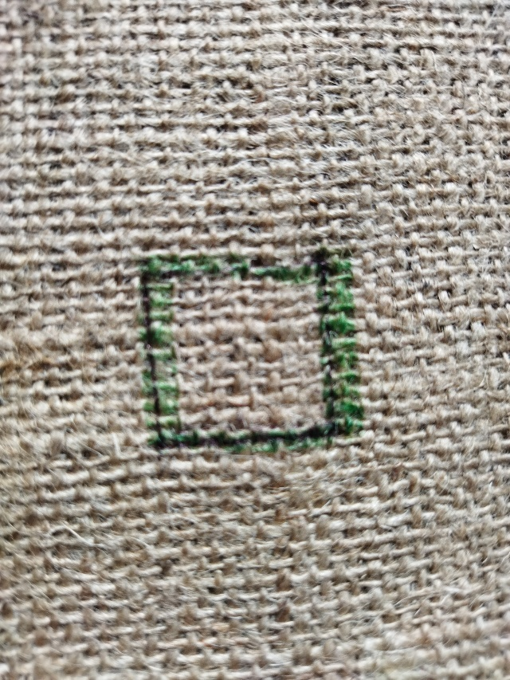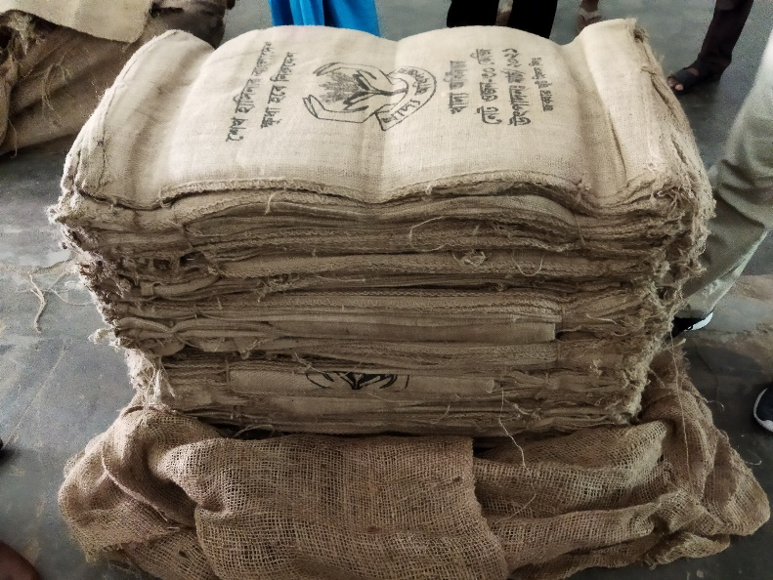

**Solution Scenario:**

Responsible person/user will capture the image using the application. The application will automatically process all image and measure all parameter according to predefine specifications like type, length, width, weight, knitting etc.

**Ideal Measurement example for Bags:**

|  |  |  |
| --- | --- | --- |
| SL | Parameter | Value |
|  | Bags Type | 50 kg |
|  | Bags Weight | 700 gm |
|  | Knitting 1 sq/ inch | 11*12 |
|  | Humidity | 16-18 |
|  | Length & Width | 37*22.5 |
|  | | |
|  | Bags Type | 30 kg |
|  | Bags Weight | 360 gm |
|  | Knitting 1 sqr/ inch | 11*12 |
|  | Humidity | 16-18 |
|  | Length & Width | 34*18 |

After image processing and measurement, the system will automatically generate a report against the products and others process will be held as usual.

**Result:**

The Selected team will need to research different image processing tools and application for finding accurate jute’s bag/bosta **Length & Width and Knitting** with all kind’s measurements. Then Selected team provide a solution for this problem.

**Research Material:**

30Kg & 50kg Real Jute’s bag sample will be provided.

**Sample Images:**

https://drive.google.com/file/d/1q6eSfsFyarRMKNoanwGTFtUePXdQf5GC/view?usp=sharing